Assignment 2
Task 1: Design Quality & Design Patterns
Author: Jason Crous (601662)
Quality Control:
Herman Bantjes (601427)
Zander De Groote (602789)

Belgium Campus iTversity
SEN-381

Table of Contents
Task 1: Design Quality & Design Patterns 2
1.1 Design-quality foundation 2
1.2 Cohesion 3
1.3 CivicConnect relevant SOLID principles 4
SRP-Single Responsibility Principle 5
OCP-Open/Closed Principle 5
DIP-Dependency Inversion Principle 6
2. CivicConnect Design Problems 7
Problem 1: Request status changes have multiple dependent consequences 7
Recommendation for Problem #1 12
Problem 2: Different request categories may require different processing rules. 12
Recommendation for Problem #2 16
Task 1: Comparison Table 17
References 17

Task 1: Design Quality & Design Patterns

1.1 Design-quality foundation
Coupling
Coupling describes how much one software component depends on other components.
For CivicConnect, high coupling could occur if, for example, a Request Service directly knows about the requester interface, email notification mechanism, database implementation, reporting code and audit logging.
That creates a problem because changing one responsibility can force changes elsewhere.
NASA's Software Engineering Handbook recommends minimal coupling between components and maximum cohesion within components, noting that this improves understandability, adaptability and maintainability (NASA, 2018).
A study published through IEEE similarly states that maintaining high-quality object-oriented software involves striving for low coupling and high cohesion, while also noting that coupling/cohesion have multiple metrics and interpretations rather than one universal measurement (Husein & Oxley, 2009).

Interpretation concerning CivicConnect:
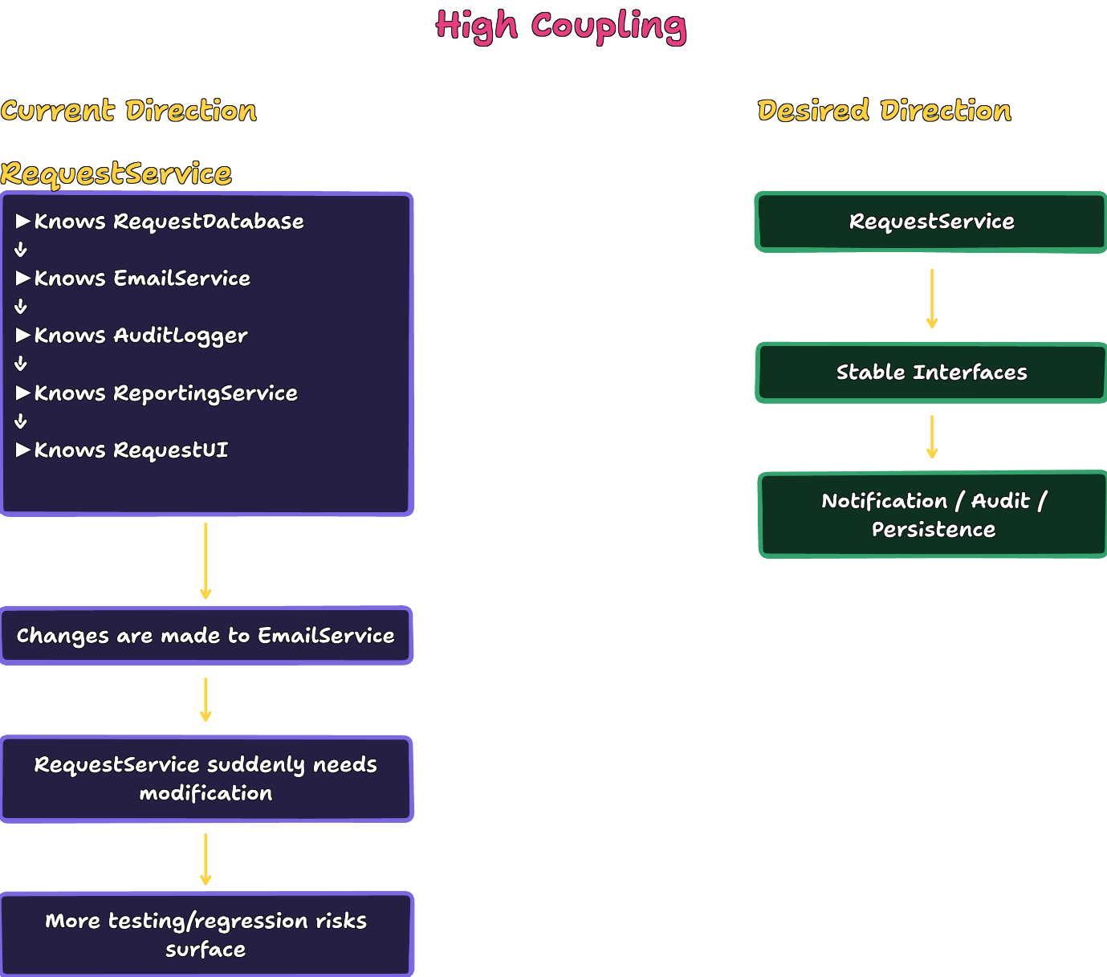

1.2 Cohesion
Cohesion is about how closely related the responsibilities inside a component are.
NASA describes cohesion as the degree to which methods within a class are related and work together to provide well-bounded behaviour. It identifies high cohesion as desirable because it supports clearer class subdivision and maintainability (NASA, 2004).

Regarding CivicConnect, one would not want something like:
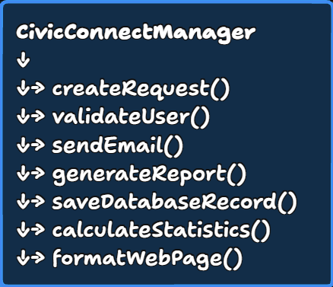
This example class has too many unrelated reasons to change—consequently increasing maintenance complexity.
A more cohesive decomposition would be:
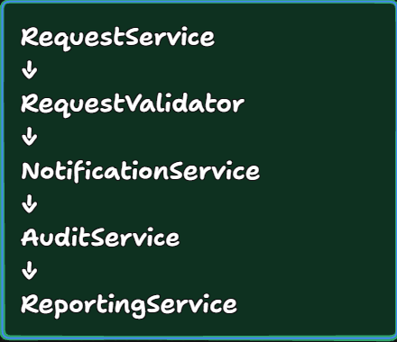
This example decomposition demonstrates stronger separation of concerns, leading to more professional approaches to design principles like maintenance and traceability, etc.

1.3 CivicConnect relevant SOLID principles
Considering our team’s discussions and research to date, we have deduced that we should focus on the following SOLID principles:

SRP-Single Responsibility Principle
Naveen describes SRP as the principle that a class should be dedicated to one specified task or function (Ramachandrappa, 2024).
This, in turn, simplifies understanding and supports future development and maintenance of the task.
For CivicConnect specifically:
A request-management component should not simultaneously be responsible for request processing, notifications, reporting and audit storage.
This reasoning supports higher levels of cohesion.

OCP-Open/Closed Principle
OCP asserts that modules or functions should be designed in a manner that advocates for future extension without requiring changes to the existing code/codebase (Ramachandrappa, 2024).
By applying the OCP, our team could minimise the risk of introducing new bugs during the development of the CivicConnect project. An extensible design allows new behaviour to be added without repeatedly modifying the main processing component.

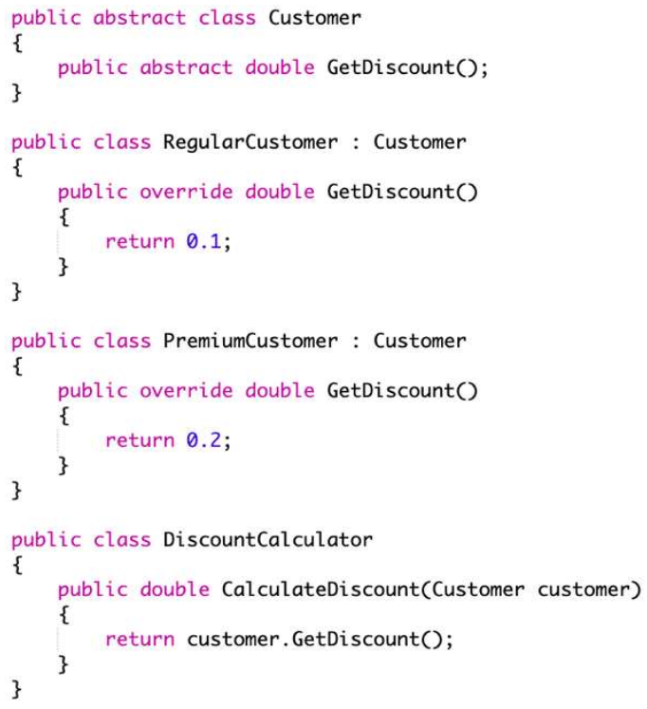

DIP-Dependency Inversion Principle
DIP is relevant when we want CivicConnect business logic to depend on abstractions rather than concrete infrastructure. This approach significantly enhances the modularity of the code, making development, testing, and maintenance much more manageable (Ramachandrappa, 2024).
For example:

This makes testing and future changes easier to implement.

2. CivicConnect Design Problems

Problem 1: Request status changes have multiple dependent consequences
CivicConnect requires controlled status changes and meaningful feedback to requesters. A status change may eventually cause several things:
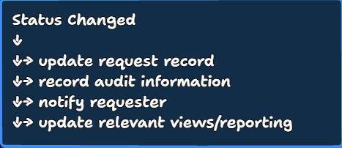
The actual design problem is:
How can CivicConnect allow multiple components to react to a request-status change without making the request-management component tightly coupled to every reaction?

Alternative A — Direct orchestration
The simplest approach is to have a service explicitly call everything it needs.
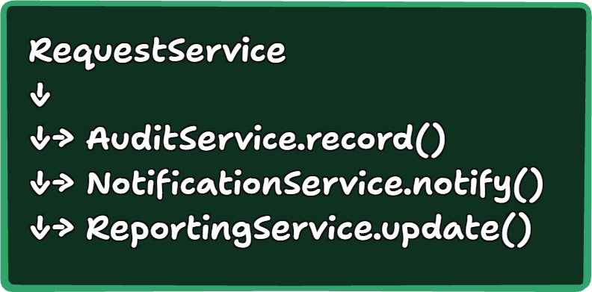
Advantages:
- Very simple.
- Easy to understand.
- Fewer abstractions.
- Easy to implement for a small system.
- Straightforward debugging.
Disadvantages:
The request service becomes aware of each dependent component.
Adding another reaction means modifying RequestService.
For example:
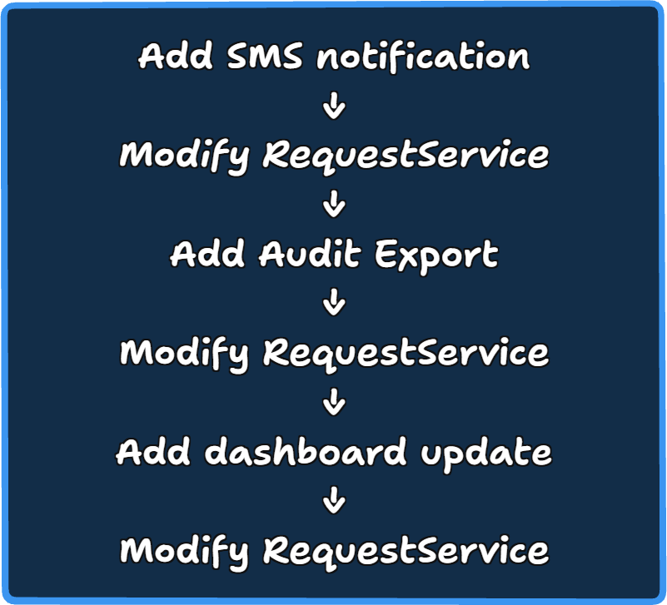
That increases coupling and gives the request service additional reasons to change.
To reflect NASA's design guidance, modularity, minimal coupling and well-defined responsibilities are specifically recommended to improve maintainability (NASA, 2018).
When it makes sense
For a small number of stable operations, this may be preferable.

Alternative B — Observer
The Observer pattern defines a one-to-many dependency in which observers can be notified when the subject's state changes. The pattern is specifically intended to reduce tight coupling between the subject and its dependents (Eales, 2005).
When applied to CivicConnect:
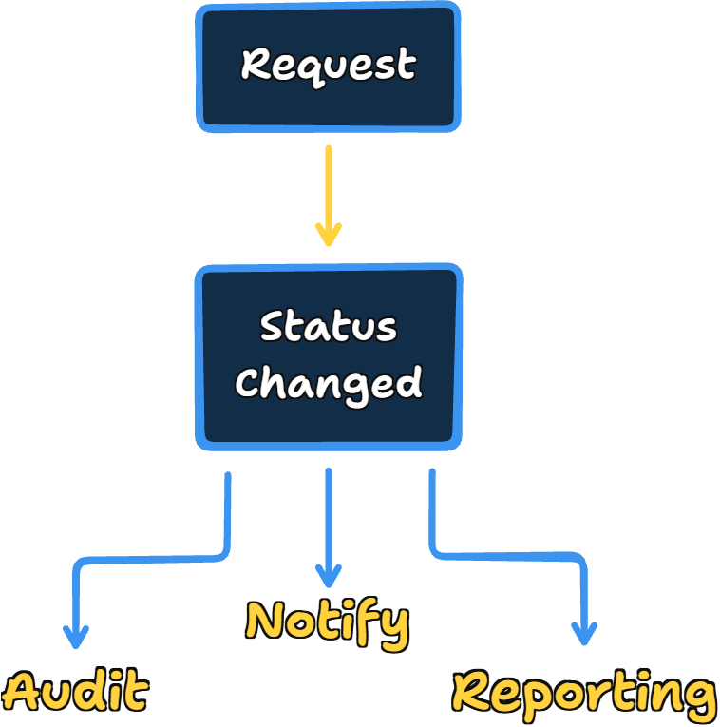
The request/status component doesn't need detailed knowledge of each consumer beyond the observer contract.
Benefits
- Lower coupling.
- New observers can be added more easily.
- Supports separation of concerns.
- Good fit for multiple reactions to a state change.
- Individual observers can be tested independently.
Limitations
Observer also introduces complexity.
The University of Pretoria's research material on Observer notes that observers are loosely coupled but also discusses the risk that a change can cascade through multiple observers (Peer, 2005).
For CivicConnect:
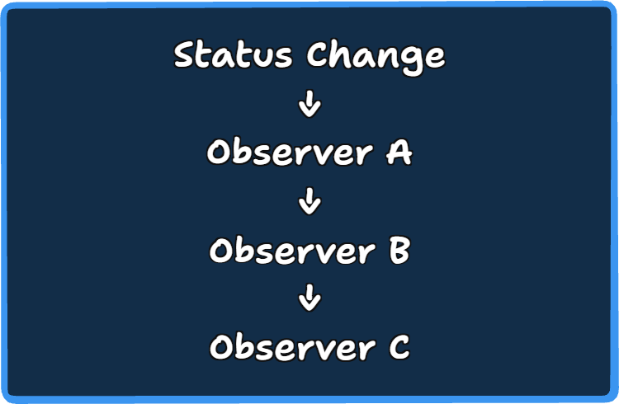
This may become harder to understand or debug if many chained reactions appear.

Alternative C — Event/notification service
A third plausible approach is an explicit application-level event or notification service.
For example:
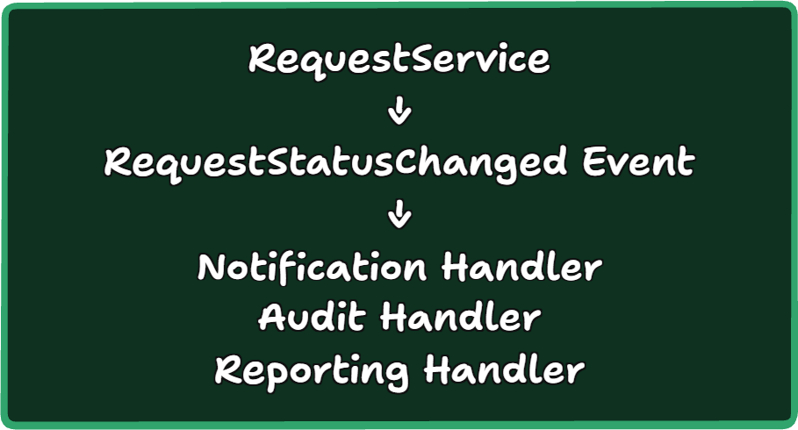
This retains some of the decoupling benefits of Observer while making the event contract explicit.
However, you should be careful not to unnecessarily turn this into a distributed messaging system. Your project constraint concerns proportional engineering, not maximum architectural complexity.

Recommendation for Problem #1

Recommended approach: Observer / application-level event notification
For the CivicConnect, our team recommends an Observer-style event mechanism, provided the team has multiple independent reactions to request status changes.
The reason is that the CivicConnect requirements naturally create multiple consumers of lifecycle changes:
- requester feedback;
- auditability;
- management visibility;
- potentially notifications.
Observer reduces the need for the core request-management component to know about each consumer, supporting lower coupling and higher cohesion. This is consistent with the original GoF motivation for Observer and broader modular-design guidance.

But we should not over-engineer it
If the implemented CivicConnect scope only has one simple reaction to a status change, direct orchestration may be better.
An important engineering conclusion:
The research supports Observer where multiple independently changing consumers exist; otherwise, the simpler direct approach may be more proportionate.
This is much stronger than saying:
"Observer is better because design patterns are good."

Problem 2: Different request categories may require different processing rules.
CivicConnect includes categories such as:
- facility faults;
- damaged equipment;
- security concerns;
- IT support;
- maintenance;
- lost property;
- other operational requests.
The design problem is:
How should CivicConnect accommodate category-specific validation, prioritisation or routing behaviour without placing an expanding collection of category-specific conditions inside one request-management component?

Alternative A — Simple conditional logic
The simplest solution could be:
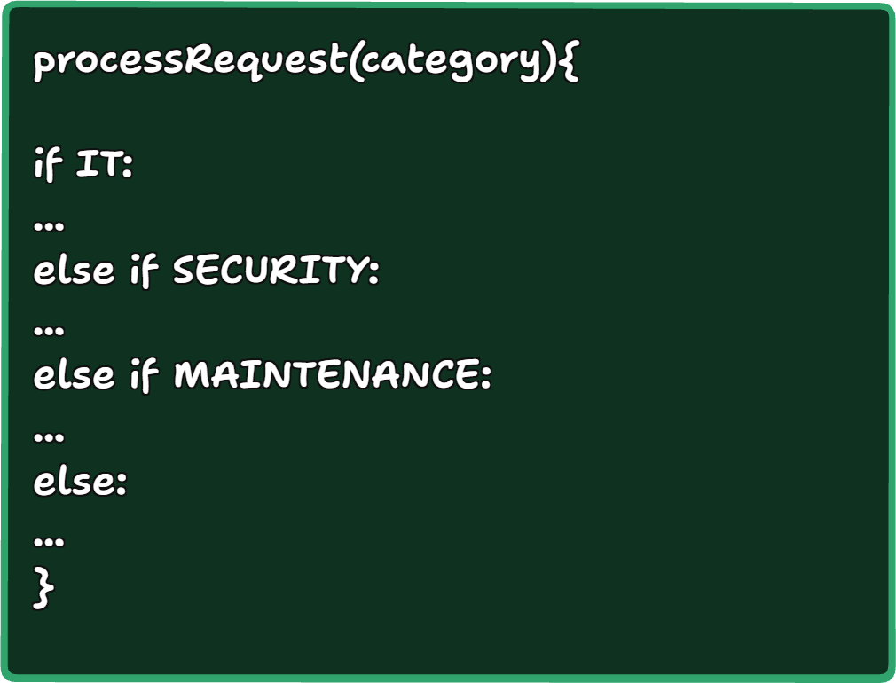

Advantages
- Very easy to implement.
- Easy for a small team to understand.
- Minimal classes.
- No additional abstraction.
- Potentially the best option when there are only a few stable categories.

Disadvantages
As the system grows, the processing class becomes increasingly responsible for unrelated category behaviours.
Adding or changing a category requires modification to existing logic.
That can lower cohesion and increase the risk of regression.

Alternative B — Strategy Pattern
The GoF Strategy pattern defines a family of algorithms/behaviours and makes them interchangeable. It is specifically suitable where a class would otherwise contain multiple conditional behaviours (Erich Gamma, 1994).
CivicConnect could theoretically have:
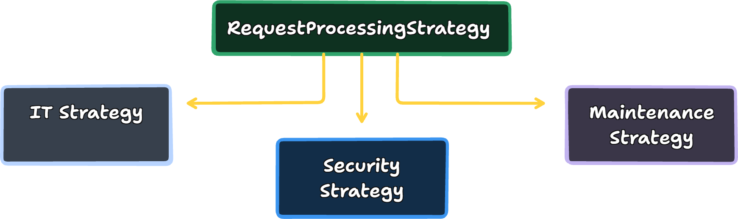
The request-processing component asks the selected strategy to perform the appropriate behaviour.

Benefits
- Separates category-specific behaviour.
- Supports OCP.
- Easier to add a new strategy.
- Individual strategies can be tested separately.
- Reduces conditional logic in the main service.

Costs
- More classes.
- More interfaces.
- More indirection.
- More complicated for a small number of stable categories.
The GoF material explicitly notes consequences such as communication overhead and object proliferation (Erich Gamma, 1994).

Alternative C — Factory Method
Factory Method could be considered when the creation of category-specific objects is itself the problem.
Its purpose is to define an interface for creating an object while allowing a subclass to determine which concrete object is created (Erich Gamma, 1994).
For CivicConnect:
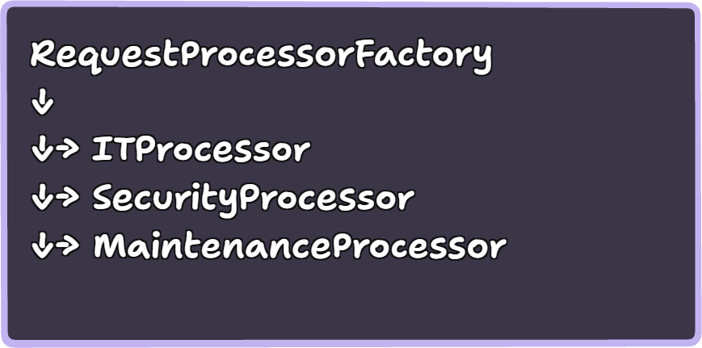

The important distinction
Factory is primarily about object creation.
Strategy is about variable behaviour.
Therefore, if the CivicConnect problem is:
"Different categories require different processing rules"
Strategy is the more direct fit.
If the problem becomes:
"The system needs to create different processor objects depending on category".
then Factory becomes useful.

Recommendation for Problem #2

Recommended approach: Strategy, if category-specific behaviour is confirmed
Strategy is the strongest candidate where different CivicConnect request categories require genuinely different processing rules.
It supports:
- lower conditional complexity;
- stronger separation of responsibilities;
- improved testability;
- easier extension of category-specific behaviour.
The research also warns against introducing Strategy when there are only a few simple, stable rules because the additional abstraction can become unnecessarily complex.
Therefore:
Use Strategy only if category-specific behaviour is sufficiently different or likely to evolve. Retain straightforward conditional logic when the category rules are few, simple and stable.

Task 1: Comparison Table
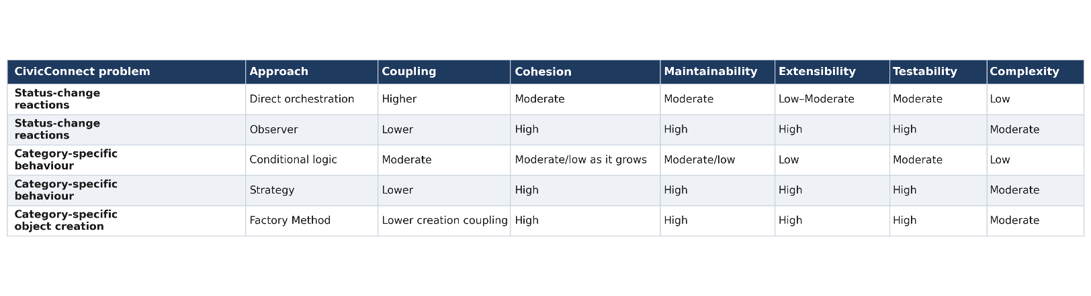

References
977304, S., 2019. OpenLab. [Online]
Available at: https://openlab.citytech.cuny.edu/girls-who-code/2019/02/05/blog-of-the-day-women-in-tech-margaret-hamilton-the-mind-behind-software-engineering/
[Accessed 02 September 2026].
Eales, A., 2005. The Observer Pattern Revisited. Wellington Institute of Technology, 1(1), pp. 1-4.
Erich Gamma, R. H. J. a. J. V. A. W., 1994. Design Patterns: Elements of Reusable Object-Oriented Software., Chicago: univ-nantes.io.
Husein, S. & Oxley, A., 2009. IEEE Xplore. [Online]
Available at: https://ieeexplore.ieee.org/document/5359706?
[Accessed 13 September 2026].
NASA, 2004. standards.nasa.gov. [Online]
Available at: https://standards.nasa.gov/sites/default/files/standards/NASA/Baseline/0/nasa-gb-871913.pdf
[Accessed 13 September 2026].
NASA, 2018. SYSTEMS ENGINEERING. 1st ed. Washington: NASA.
Peer, E. S., 2005. A Serendipitous Software Framework for Facilitating Collaboration in Computational. University of Pretoria etd, 1(5), pp. 1-242.
Ramachandrappa, N. C., 2024. SOLID Design Principles in Software Engineering. International Journal of Computer Trends and Technology, 72(9), pp. 18-23.
Stephen Carney, 2025. NASA.gov. [Online]
Available at: https://science.nasa.gov/mission/mars-climate-orbiter/
[Accessed 02 September 2026].

